**EE4212 Part 2 CA 2 Report**

Ananya Das, A0126632L

# Question 1

The de-noised image using m_lambda = 35 is shown below.



# Question 2

Results using k = 2

 

 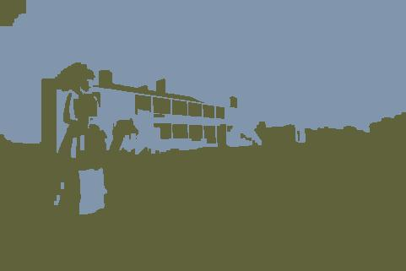 

Results using k = 4

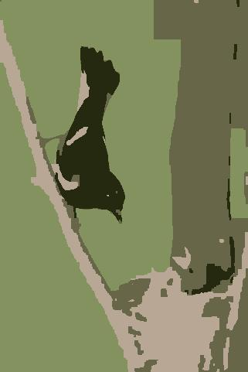 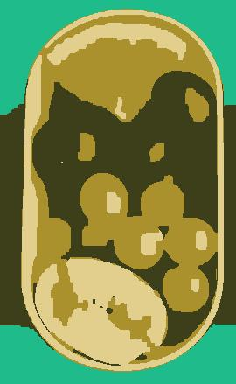 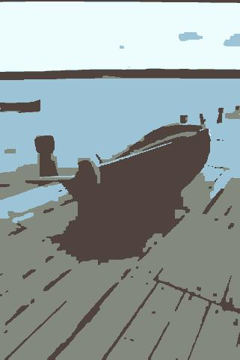

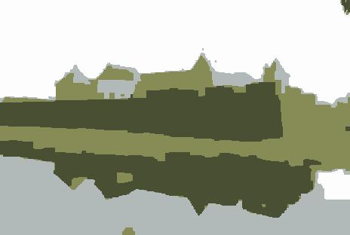 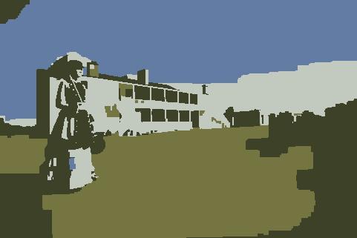 

Results using k = 6

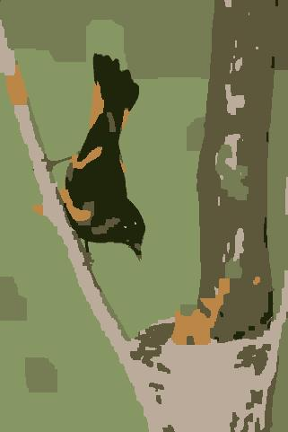 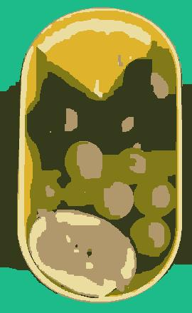 

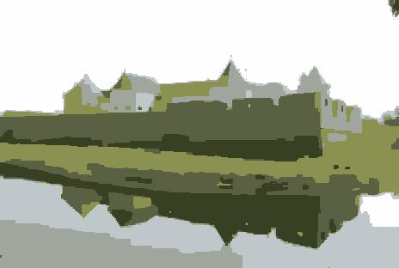 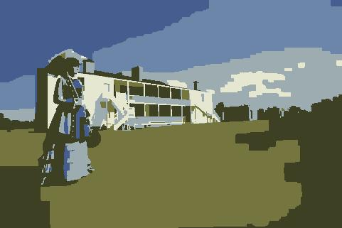 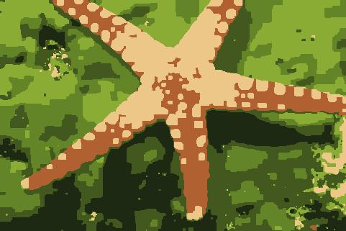

Results using k = 10

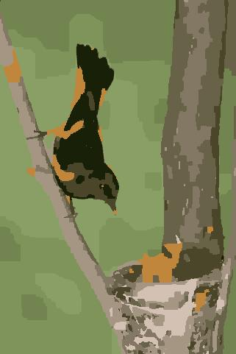 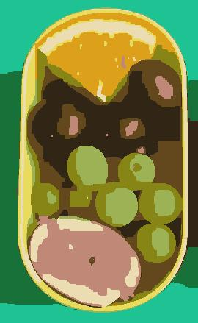 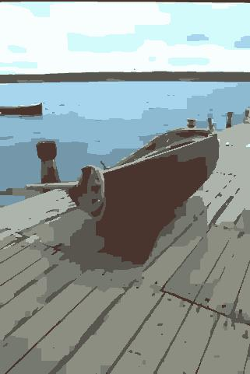

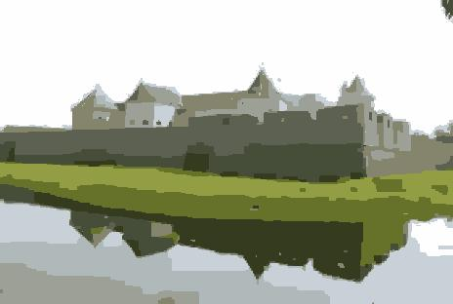 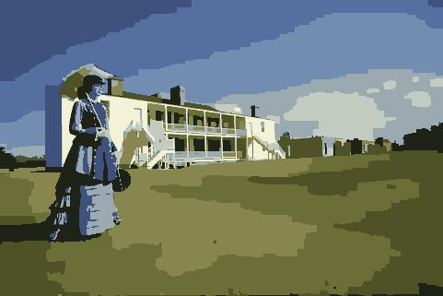



Discussion:

Color alone is not a sufficient feature for good segmentation. Using only color makes the segmentation very susceptible to illumination, as seen in the fruits image for example. Even increasing the number of colors is not helpful against shininess from illumination – this algorithm is more suited for Lambertian surfaces. Using texture or other cues together with color for segmentation may yield better results, even with fewer mean colors used for segmentation.

I think k-means graph cut might not work well on noisy images. If there is pepper noise like in question 1, the k-means algorithm will take it into account to choose the colors, which might affect the quality of the overall image. K-means graph cut is not able to identify and remove noise in the image on its own. Thus perhaps k-means graph cut could be combined with some denoising algorithms to get good segmentation even with noise in the image.

It has also been suggested to use graph cut in conjunction with superpixel calculating algorithms in order to reduce computational load on the graph cut algorithm.